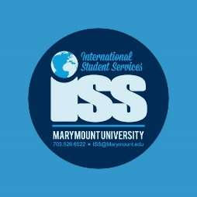

International Student Orientation Sessions

Wednesday, August 21nd, 8:45am-4:00pm

Reinsch Library Auditorium
(Some minor changes may be made based on speakers’ availability)

8:45-9:15 Orientation Registration and Breakfast

9:15-9:30 Welcome and Introductions

9:30- 10:00 Life at Marymount and in a new Culture -
ISS staff and Peer Advisors will give you a brief overview of navigating the American Culture and how to unlock your own potential to make the most of this experience. share their stories.

10:00-11:00 Success in the American Classroom –
ISS staff and Peer Advisors will share tips on Academic advising, registration and learning resources and how to succeed in the American Educational System.

11:00-11:15 Break

11:30-12:30 Immigration, Employment and Your Legal Responsibilities
ISS Advisors will go over important information about how to maintain your legal status while studying in the United States. They will also give you brief information about employment eligibility.

12:30 to 2:00 Lunch at Dining Hall – Zone 1 and 2 & Peer advisor Panel
Peer advisors and student leaders will share lunch with students in smalls groups and then the student panel will answer any of your questions.

2:00 to 3:00 Academic Writing and Research in U.S. Education.
Library Tour Activity / Academic Integrity
Overview of Marymount’s Library collections, research resources and discussion on academic integrity standards in the U.S.

3:00-4:00 Healthcare system in the U.S. and Wellness for MU Saints

Student Health Center, Counseling Center, Title IX or consent Will give overview Health Insurance coverage, waivers and Medical records requirements. They will also give tips and resources to keep a healthy and safe lifestyle while you study at Marymount.

4:00-5:00 Take care of business. Peer advisors and staff will be around for individual questions.

