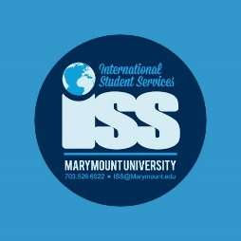

International Student Orientation Sessions

Thursday January, 8:30am-12:00pm

Caruthers 1021

8:30-9:00 Orientation Registration and Breakfast

9:00-9:45 Welcome and Introductions

Life at Marymount and in a new Culture
ISS staff and Peer Advisors will give you a brief overview of navigating the American Culture and how to unlock your own potential to make the most of this experience. share their stories.

9:45 – 10:00 Community Builder and Picture

10:00-10:45 Immigration, Employment and Your Legal Responsibilities
ISS Advisors will go over important information about how to maintain your legal status while studying in the United States. They will also give you brief information about employment eligibility.

11:00-12:00 Success in the American Classroom
Academic Writing and Research in U.S. Education. research resources and discussion on academic integrity standards in the U.S

Overview of Marymount’s Library collections. Scavenger Hunt activity.

ISS staff and Peer Advisors will share tips on Academic advising, registration and learning resources and how to succeed in the American Educational System.

12:00 to 2:00 Welcome Lunch at Dining Hall with Orientation Leaders and Color Groups
The president will welcome the new class
Orientation and student leaders will share lunch in their color groups

2:00 to 5:00 New student Orientation (Mandatory for First Year and Transfer students)

Friday January 10th at 3:00 Graduate Student Orientation

