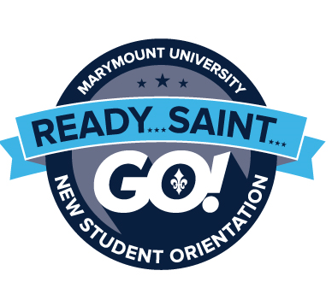
International Student Session
Wednesday, August 22, 2018
International students bring their own unique needs to Marymount. The International Student Session, includes many different topics including cultural transition issues, immigration and legal responsibilities, employment, and banking. Students will also have plenty of time for meeting other international and American students. All incoming undergraduate and graduate international students are required to attend the International Student Session on Tuesday from 8:45am-5:00pm, in addition to the New Student Orientation August 22-26.
Dress for Tuesday is casual.
Welcome to Marymount!
Wednesday, August 22, 2018
Welcome to Marymount! On Wednesday, between 9:00am-5:00pm, students will have the opportunity to visit offices around campus and check-in for New Student Orientation! All first-year and transfer athletes will meet at 5:00pm to learn more about their responsibilities and expectations, and to speak with other athletes.
In addition to New Student Orientation check-in, all resident students will move-in to their resident hall between 9:00am-5:00pm. Student will meet their new roommate and settle into their new home. Residential students will meet their Resident Assistant and peers at 9:00pm in the year’s first hall meeting.
Intellectual Curiosity
Thursday, August 23, 2018
Thursday kicks off with a continental breakfast for both parents and students, followed by our annual convocation, the official opening of the academic year. The day continues with an opportunity for students to explore academic programs and available resources, and to meet faculty advisors and peers in the student’s unique major or program. While students are learning about academic services and resources, parents will have an opportunity to speak with the parents of former or current students to get a first-hand perspective on the benefits and challenges of the Marymount experience. At 4:30pm, student and parents will come together at the President’s Reception at the new Ballston Center. Members of the Honor’s program and their families are invited to attend the Honor’s Reception, which will also be held at 4:30pm. From 7:00-10:30pm, students will meet their Orientation Leader, and other members of their Color Group, for an exciting round of skits and small group discussions. Dress for students and parents on Thursday is business casual.
Service to Others
Friday, August 24, 2018
Friday is an opportunity to learn more about Marymount’s culture of service, diversity, and inclusion in the community. The day begins at 9:00am with Color Group time. Throughout the day, students will work with each other as part of the Saintserve community engagement project; learn more about service, diversity, and inclusion through discussions and dialogue; and have the chance to learn more about specific topics and programs that are unique to the Marymount experience. At 8:30pm, all students are encouraged to attend the evening Block Party to enjoy music and casino games! Dress for Friday is casual.
Global Perspective
Saturday, August 25, 2018
Saturday begins at 8:00am with breakfast, followed by an exciting trip into Washington D.C. with the Orientation Leaders! New Student Orientation will conclude with a group photo and the closing ceremony at 4:00pm. Saturday evening is the official kick-off of the Saints Welcome Week, which will include a celebration and concert with a special surprise guest at 8:00pm! Dress for Saturday is casual and comfortable.
Saints Welcome Week
Sunday, August 26 –Monday September 3, 2018
The fun doesn’t stop here! Keep your eyes open for more information about Saints Welcome Week festivities, including a Color Group Reunion Challenge on Sunday from 3:00-5:00pm and the Welcome Back Mass and Social from 7:00-10:00pm!

