Transcription Capture on Zoom

- Log into MyMU Portal
- Under Sign-On Links click “Zoom”
- Create/host the meeting

- When window prompts you, click “Open URL:Zoom launcher”
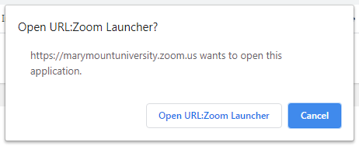

- Join with either computer audio or microphone.
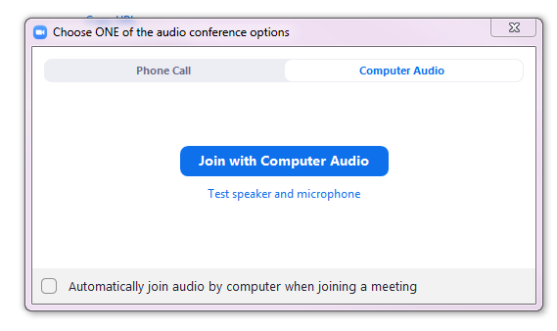

- When preparing to start the meeting, click “Record” then click “Record to Cloud”. A recording notification will appear in the top left of the meeting window. Computer/Local recordings are not transcribed.
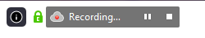
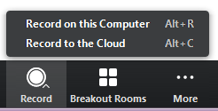

- When the meeting is over, press the square icon in the top left recording window or on the bottom of the meeting window. A notification will appear. Click “Yes”.

- There is a time delay between recording and video processing. Once you receive the email notification that processing is complete, log back into MyMu Portal, go to Zoom and click “Recordings”.
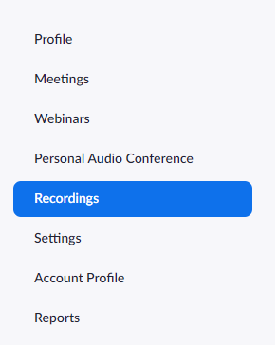

- Select the meeting you want to review by clicking on the title.

- To review/edit the transcript, click on the video icon.
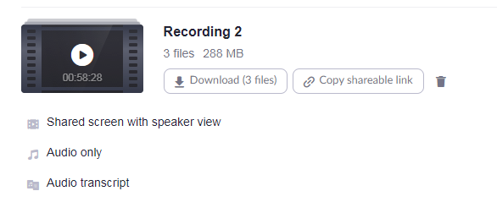

- The video will open and the transcript will appear on the right side of the window. The text will bold as the video plays for easy following. Transcription is also timestamped.
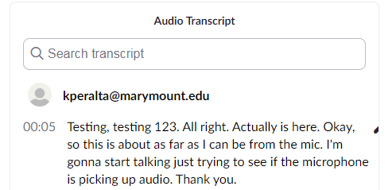

- To edit the transcript, hover over the text you wish to edit until you see a small pencil icon on the right side of the text. Click the pencil.

- You can then edit the text to fix any errors or add clarification. Click “Save” once done.
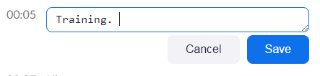

- Once saved, a green notification will appear at the top of the video confirming the text has been updated.
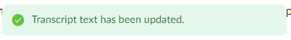

- Continue to read through the transcript to ensure all audio has been captured and corrected.
- Once all corrections have been made, you can then download the file if you wish to upload it to Canvas. The file will download as a “.vtt” file which should be viewable in the Notepad program. Audio and transcript files can also be shared via a link.

